Medical Applications of Wireless Networks.pdf
A wireless body area network of intelligent motion sensors for computer assisted physical rehabilitation
Emil Jovanov,¹ Aleksandar Milenkovic,¹ Chris Otto,¹ and Piet C de Groen²Medical Applications of Wireless Networks
Abstract:
Coming along with the urgent development of wireless technology, wireless devices have invaded the medical area with a wide range of capability. Not only improving the quality of life of patients and doctor-patient efficiency, wireless technology enables clinicians to monitor patients remotely and give them timely health information, reminders, and support – potentially extending the reach of health care by making it available anywhere, anytime.
In this survey paper we discuss advantages of wireless medical devices and challenges involved in this technology. We focus on Wireless Personal Area Network technologies, WiMAX, WiFi and Zigbee. We have also investigated standards being used in wireless medical applications and location of wireless network in a healthcare system. Finally, we identify innovative medical applications of wireless networks developed or being developed in research, projects and research groups on wireless medical application, and commercial products.

Keywords: medical applications survey, wireless medical applications, wireless networks, sensor networks, wireless applications, wireless homecare, Zigbee, Bluetooth, WPAN, WiFi, patient management, CodeBlue, CIMIT, wireless medical solutions, MobileFi, IEEE 802.20.
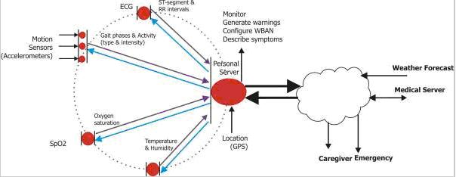
Figure 1: Dataflow in computer assisted physical rehabilitation system [Pubmed05]

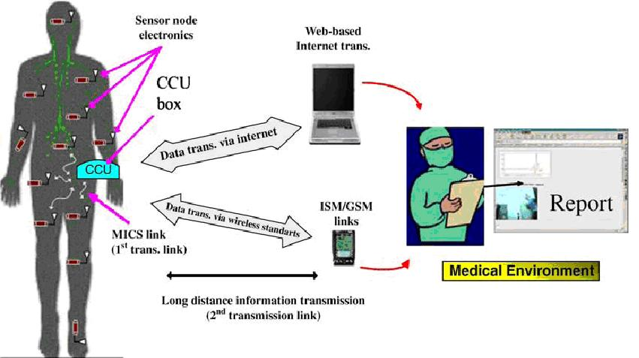
Figure 2: A medical sensor network application [Yuce07].
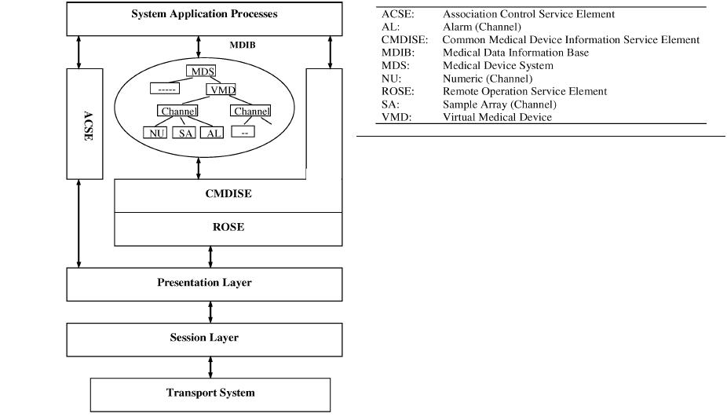
Figure 3: Conceptual model for X73-based medical devices [Yao05].

OSI layers | ISO/IEEE 11073 standards
Application | ISO/IEEE 11073-10xxx: Medical Device Data Language (MDDL)  ISO/IEEE 11073-10101 MDDL Nomenclature  ISO/IEEE 11073-10201 Domain Information Model  ISO/IEEE 11073-1030x Device Specializations  ISO/IEEE 11073-20xxx: Medical Device Application Profile
Presentation | In ISO/IEEE 11073-20101
Session | In ISO/IEEE 11073-20101
Transport | ISO/IEEE 11073-30xxx: Transport Profile
Network | ISO/IEEE 11073-30xxx: Transport Profile
Data link | ISO/IEEE 11073-30xxx: Transport Profile
Physical | IEEE 1073.4.1 Physical Layer;  Cable-Connected Mode (Withdrawn)
Table 1: mapping between IEEE11073 sub-standards and the OSI reference model[Yao05].
Some other IEEE standards are:
- IEEE 1073.0.1.1 "Health informatics - Point-of-care medical device communication - Technical report - Guidelines for the use of RF wireless technology"
- IEEE 1073.3.5 (Health Informatics -Framework and Overview Structure for Wireless Medical Data Transport using Personal Area, Local Area, Wide Area, and other Wireless Networks)
- IEEE 1073.3.5.3 (Health informatics - Point-of-care medical device communication - Transport profile - RF wireless - Local area network (wLAN))
- IEEE 1073.3.5.5 (Health informatics - Point-of-care medical device communication - Transport profile - RF wireless - Wide area (Mobile Phone) Network (wWAN))
- IEEE 1073.2.1.3 (Health informatics - Point-of-care medical device communication - Application profile - Clinical context management (CCoM))
- IEEE 1073.1.3.16 (Health Informatics - Point-of-Care Medical Device Communication - Device Specialization - Dialysis Device)

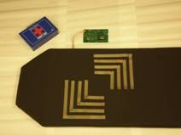
Figure 4: SmartPad - A Wireless, Stickerless EKG System[CIMIT]

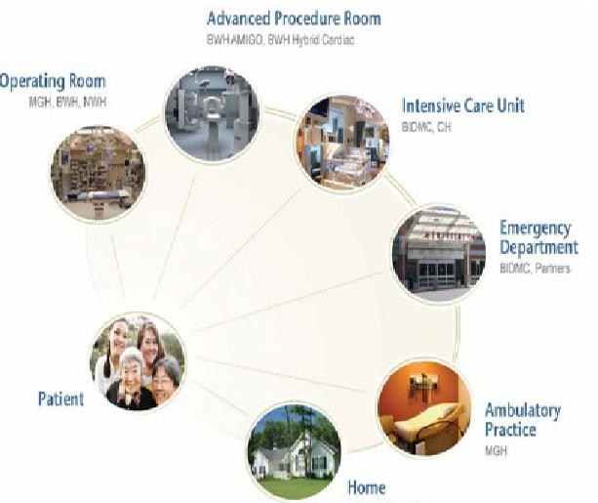
Figure 5: Future clinical system [CIMIT].

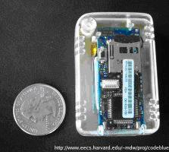
Figure 6:Intel SHIMMER motes[CodeBlue]

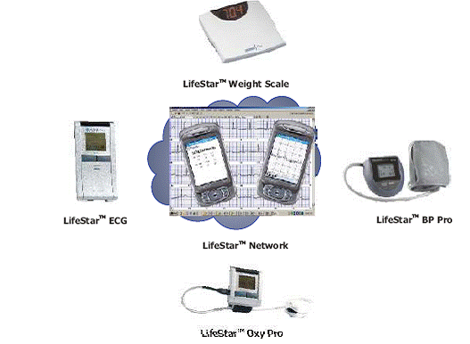
Figure 7: UVa/AID-N "eTag" wireless triage tags with pulse oximeters [CodeBlue].

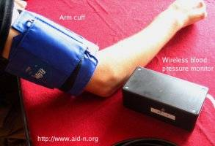
Figure 8: UVa/AID-N wireless blood pressure cuff [CodeBlue]
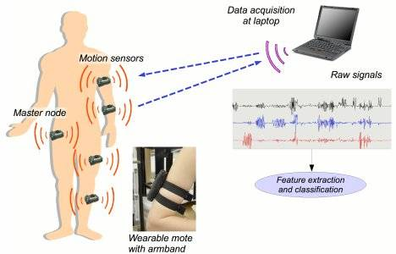
Figure 9: Stroke patient rehabilitation monitoring system [CodeBlue].

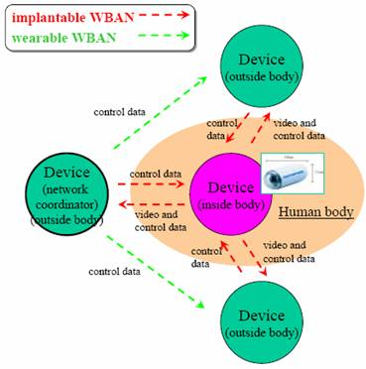
Figure10: Between wearable WBAN and implanted WBAN[Takizawa08]
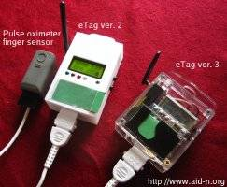
Figure 11: Wireless vital signs monitoring system [Lifestar].
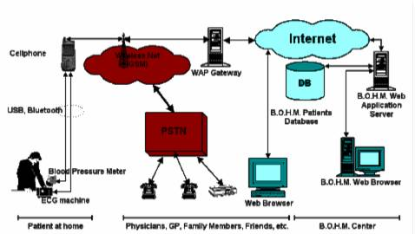
Figure 12: Patient’s blood pressure and ECG monitoring [BOHM].

WiMAX: Worldwide Interoperability for Microwave Access
WiFi: Wireless Fidelity
WPAN: Wireless Personal Area Network
WBAN: Wireless Body Area Network
ASTM: American Society for Testing and Materials
CIMIT: Center for Integration of Medicine and Innovative Technology
QoS: Quality of service
ECG: electrocardiogram
EMSS: emergency medical services system
PDA: Personal Digital Assistant
Micro-Electronic Mechanical Systems (MEMS)

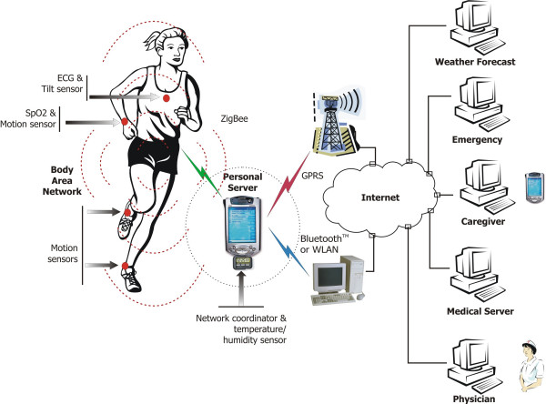
Wireless Body Area Network of Intelligent Sensors for Patient Monitoring
http://www.ncbi.nlm.nih.gov/pmc/articles/PMC552302/figure/F1/
A block diagram of the sensor node
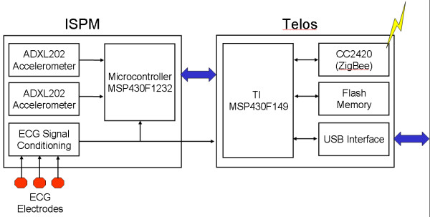
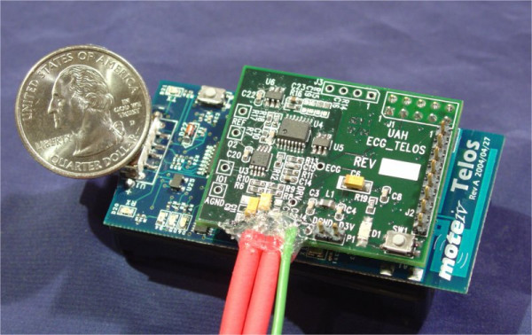
Intelligent Signal Processing Module – ISPM
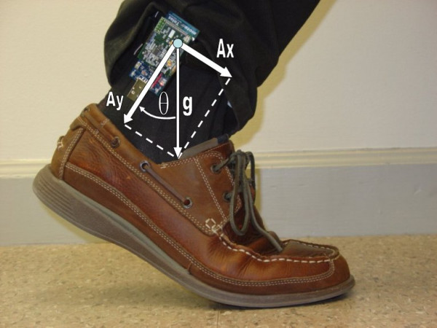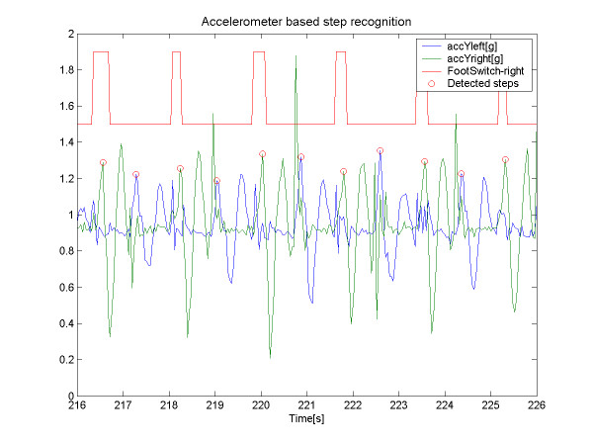

Activity sensor on an ankle with symbolic representation of acceleration components AND
Accelerometer based step detection using ankle sensors

